

**School of Computer Science and Information**  **Technology**

**Department of Computer Science and Information**  **Technology**

**Semester: IV Specialisation: Internet of Things (E)**

# 23BCA4VC02: Network Administration

**Activity 2**

***AUTOMATED BACKUP SYSTEM***

***(Simulation on CISCO Packet Tracer)***

**Date of Submission: 26-04-2025**

**Submitted by:**

**Name: YASH JAIN**

**Reg No./USN No: 23BCAR0345**

**Signature: Faculty In-Charge:**

**Mr. Sahabzada Betab Badar**



## CERTIFICATE

This is to certify that **yash jain** has satisfactorily completed activity prescribed by JAIN (Deemed to be University) for the fourth semester degree course in the year 2024-2025.

|  |  |  |  |
| --- | --- | --- | --- |
| **Sl.**  **No** | **CRITERIA** | **MARKS** | **MARKS**    **OBTAINED** |
| **1** | **On-time Submission** | **5** |  |
| **2** | **Presentation Skill** | **10** |  |
| **3** | **Communication Skill** | **10** |  |
| **4** | **Content with example program** | **15** |  |
| **5** | **Documentation** | **10** |  |
|  | **Total** | **50** |  |
|  | **Convert** | **15** |  |

|  |  |
| --- | --- |
|  | **MARKS** |
| **MAX** | **OBTAINED** |
| **15** |  |

Signature of the Student Signature of the Faculty

Date of Submission: 26th April, 2025

## INDEX



|  |  |  |  |
| --- | --- | --- | --- |
|  | | **Online of the Enterprise**  **Network Simulation** |  |
| **Sl. No.** |  | **Table of Content** | **Page No.** |
| 1 | Introduction |  | 4 |
| 2 | Background |  | 4 |
| 3 | Discussion |  | 4 |
| 4 | Challenges |  | 5 |
| 5 | Implemetation |  | 5-9 |
| 6 | Conclusion |  | 10 |
|  |  |  |  |

**GitHub Repository Link:**

https://github.com/YASHJAIN2121/NA

### 1. Introduction

This project demonstrates how to configure a DHCP Server on a Cisco Router and implement Port Security on a Cisco Switch using Cisco Packet Tracer. The goal was to automate IP address assignment across the network while securing switch ports from unauthorized devices. This project helps understand practical aspects of enterprise network setup, device security, and automatic addressing.

### 2. Background

Dynamic Host Configuration Protocol (DHCP) allows network devices to obtain IP addresses automatically without manual configuration. In enterprise networks, routers often act as DHCP servers to simplify device management.  
Port Security is used to protect switch ports by restricting the number of devices that can connect to each port, preventing unauthorized network access.

This project focuses on:

* Setting up a router as a DHCP server.
* Implementing sticky MAC-based Port Security.
* Testing device connectivity and automatic IP allocation.
* Verifying switch protection against unauthorized devices.

### 3. Discussion

The network is designed with one Cisco Router (2911), one Switch (2960), and two PCs.

* The router acts as a DHCP server and gateway for the PCs.
* PCs are connected to the switch, which is configured with port security.
* DHCP automatically assigns IP addresses to PCs from a specified range.
* Port Security is enabled on the switch port connected to PC1, allowing only one MAC address and preventing port misuse.

After setup, PCs received IP addresses automatically via DHCP, and unauthorized device connections triggered port security actions.

### 

### 4. Challenges

Some key challenges faced during the project:

* Properly configuring DHCP pools to match the correct network and router interface.
* Ensuring router interfaces were active (no shutdown) to allow DHCP broadcast.
* Correctly applying port security commands on the switch ports.
* Testing port violation behavior (disconnecting PCs and observing the port status).
* Making sure excluded addresses in DHCP did not overlap with client IP pools.

### 5. Implementation

**Devices Used:**

* **1 Cisco 2911 Router**
* **1 Cisco 2960 Switch**
* **2 PCs**
* **Copper Straight-Through Cables**

**IP Address Setup:**

* **PC1 and PC2: Dynamic IPs from DHCP Pool (range: 192.168.1.6 - 192.168.1.254)**
* **Router (G0/0): 192.168.1.1/24**

**Configuration Steps:**

1. Physically connect PCs to Switch, and Switch to Router.
2. Configure router interface:

bash

Copy code

enable

configure terminal

interface GigabitEthernet0/0

ip address 192.168.1.1 255.255.255.0

no shutdown

exit

1. Configure DHCP:

bash

Copy code

ip dhcp excluded-address 192.168.1.1 192.168.1.5

ip dhcp pool LAN

network 192.168.1.0 255.255.255.0

default-router 192.168.1.1

dns-server 8.8.8.8

exit

1. Configure Switch Port Security on port connected to PC1:

bash

Copy code

enable

configure terminal

interface fastEthernet0/1

switchport mode access

switchport port-security

switchport port-security maximum 1

switchport port-security mac-address sticky

switchport port-security violation restrict

exit

1. Set PCs to **DHCP mode**.
2. Verify IP addresses received and test Ping between PCs.
3. Test Port Security by plugging another PC into Fa0/1 and observing restriction.

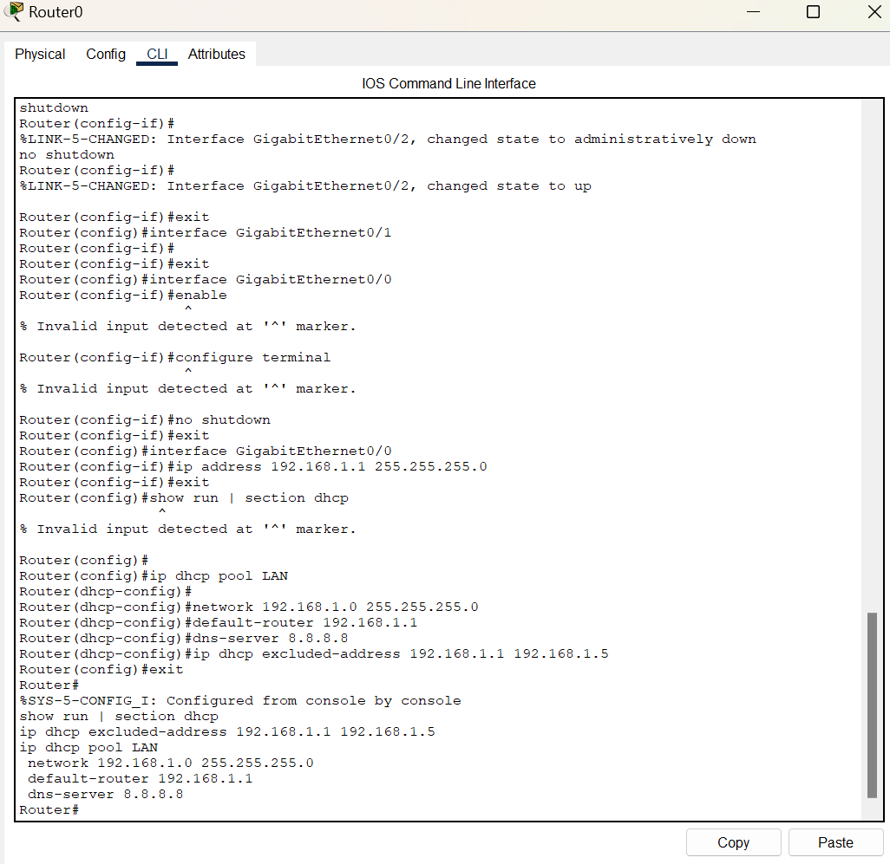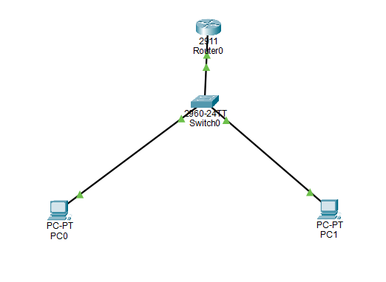

### 6. Conclusion

### This simulation successfully demonstrated setting up a DHCP server on a Cisco Router and securing switch ports using Port Security. The network automatically assigned IP addresses to connected PCs, and unauthorized device connections were prevented using MAC address-based security. This project enhanced understanding of dynamic IP management, network access security, and real-world troubleshooting in enterprise environments.

### 